One hospital which is “getting it right” is the University of California, San Francisco (UCSF) Medical Centre. UCSF is a public and a non-profit hospital which is located in San Francisco, California. The UCSF Medical Centre is renowned internationally as a healthcare facility which provides healthcare that is highly innovative and specialized. The hospital is among the leading in the United States as it has become the site for all medicine specialties breakthrough due to the presence of UCSF School of Medicine. The hospital is able to drive advancements in treatments and technology which benefit patients as the leading experts in every health area are brought together from all over the world. UCSF Medical Center has a team of doctors who treat from the rarest conditions to the surgeries that are most complicated and every condition of a patient has an expertise. It has made health care be accessible to everybody through caring, teaching, healing and discovering as the hospital delivers the best health care possible. The hospital improves their patient with the best possible health outcomes as they tackle the most difficult challenges pushing innovation further. The hospital promotes teamwork which has enabled it to get most of the expertise, skill, research findings and innovation that makes it flourish. Besides, the hospital has many state-of-the-art complexes like Mission Bay which has a 600-bed teaching hospital and extensive abs for research. (California, 2014) The pictures below show the Mission Bay facility.
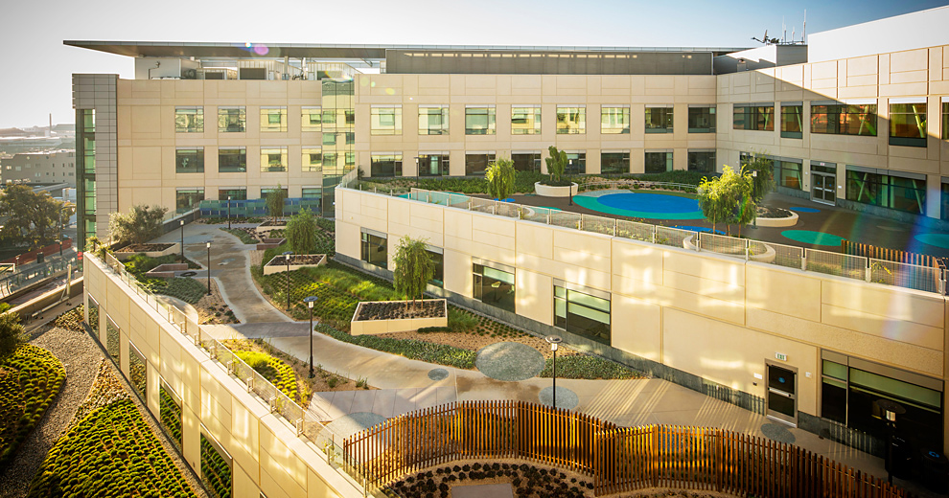

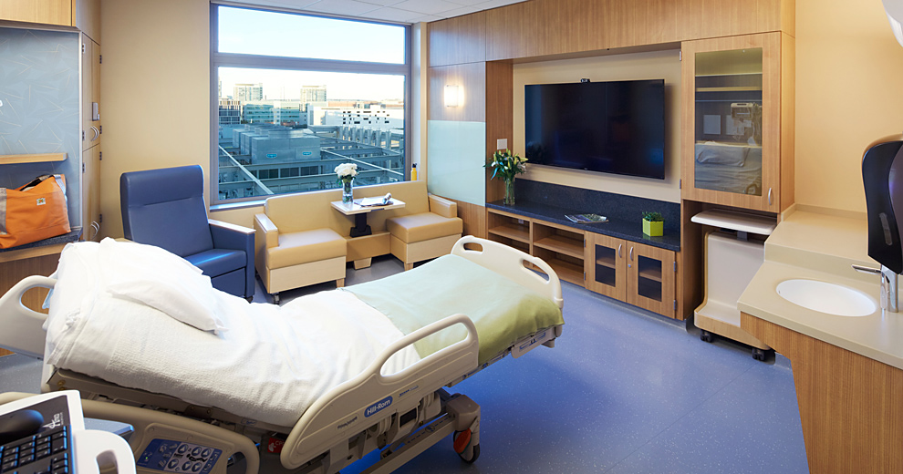
The University of California, San Francisco (UCSF) Medical Centre has a positive impact on the patient population. The first positive impact is providing the highest-quality patient care and service. For example, there is the commitment of UCSF Medical Center and UCSF Children’s Hospital to provide the patient population with the highest-quality and safest care. The second impact is improving the health outcomes of the patient population through research and innovation in designing their facilities. The Mission Bay is an example which shows how the health of patients can be improved the design as suggested by the research and this has become a prevalent trend. The Mission Bay increases the safety of patients and reduces the stress among the patient population, their families and the hospital staff as well which improves the health outcomes for all. (Stannard & Krenzischek, 2012)

References
Stannard, D., & Krenzischek, D. A. (2012). Perianesthesia nursing care: A bedside guide for safe recovery. Sudbury, MA: Jones & Bartlett Learning.
California. (2014). UCLA and UCSF Medical Centers: Although they supply significant monetary support to their campuses' schools of medicine, their finances and key measures of patient-care quality have remained stable.

